**Задание по поиску – 4110-2-Тренинг**

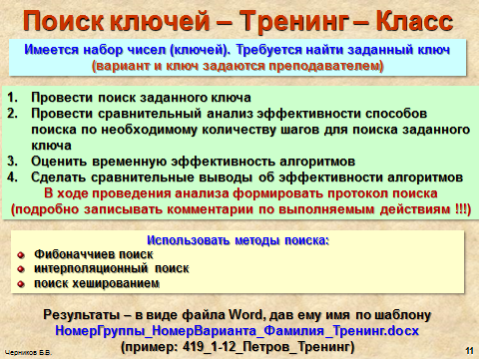

|  |  |
| --- | --- |
| **Вариант** | **Заданный набор ключей** |
| **2–15** | 12,14,14,15,22,22,28,31,31,36,36,42,46,47,49,51,51,53,56,57,58 |
| **2–16** | 10,10,14,16,17,18,18,20,20,21,21,25,26,28,39,39,41,42,45,45,47 |
| **2–17** | 12,14,16,17,18,20,20,21,24,24,26,26,34,36,38,39,42,43,43,46,47 |
| **2–18** | 10,12,15,16,17,21,22,22,25,25,27,28,29,30,31,37,38,47,49,52,56 |
| **2–19** | 11,13,13,15,16,18,19,23,25,26,28,29,29,31,37,39,40,430,41,46,47 |
| **2–20** | 16,18,19,21,26,27,28,28,32,36,38,39,45,47,48,48,49,51,51,53,56 |
| **2–21** | 12,13,14,14,15,17,18,20,21,21,24,27,28,31,35,37,39,39,45,45,47 |
| **2–22** | 15,15,16,16,18,18,24,26,28,29,34,37,39,41,42,45,46,46,47,48,48 |
| **2–23** | 24,24,26,28,31,33,35,38,43,43,52,53,54,55,55,56,58,58,63,66,68 |
| **2–24** | 11,15,15,17,23,23,24,26,37,37,38,39,45,47,52,54,54,56,56,59,62 |
| **2–25** | 12,14,15,17,19,21,24,25,26,26,28,34,35,38,41,43,43,46,48,48,52 |
| **2–26** | 18,19,19,26,26,27,27,29,29,35,36,38,45,49,49,52,53,53,55,55,57 |
| **2–27** | 27,29,36,39,42,42,44,47,57,59,59,63,64,68,68,73,74,74,75,77,78 |
| **2–28** | 4,4,6,7,7,9,9,10,12,13,13,14,15,17,17,18,19,21,24,25,26,26,28,34 |
| **2–29** | 15,16,18,18,19,19,21,26,26,27,27,29,29,35,36,36,38,40,42,45,49 |
| **2–30** | 36,39,42,42,47,52,55,57,57,59,63,63,64,65,68,69,69,73,74,74,76 |
| **2–31** | 15,17,17,19,22,22,24,26,28,28,33,33,42,42,47,47,58,58,59,61,63 |
| **2–32** | 13,15,16,17,19,22,23,25,26,28,35,37,41,41,43,45,45,47,48,48,53 |
| **2–33** | 21,23,23,26,27,27,28,35,35,37,39,41,41,48,48,51,53,53,59,67,68 |
| **2–34** | 22,23,23,36,37,38,38,42,47,47,53,56,56,69,69,73,73,78,78,81,83 |
| **2–35** | 11,14,14,16,16,17,18,20,20,21,23,24,26,26,33,36,36,38,39,42,47 |